Machine Learning Classification – Assignment

In this dataset we need to find the Chronic kidney disease. We have 27 input and one output columns so this is under supervised learning. We have categorical data so use getdummies to convert into number. Under classification I used logistic Regression using grid classification.
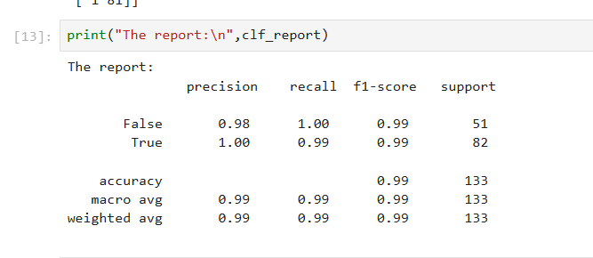
F1 score and accuracy is 0.99 and my model performed well using logistic Regression in classification.
The f1_macro value for best parameter {'penalty': 'l2', 'solver': 'newton-cg'}: 0.9924946382275899
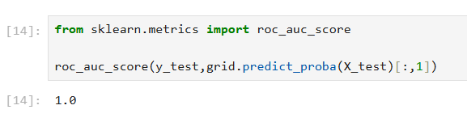
Roc is 1

